Bivariate numerical data

introduction to scatterplots

Constructing a scatter plot

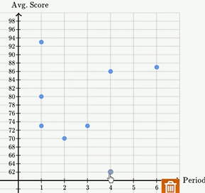

There is no obvious trend.

Example of direction in scatterplots
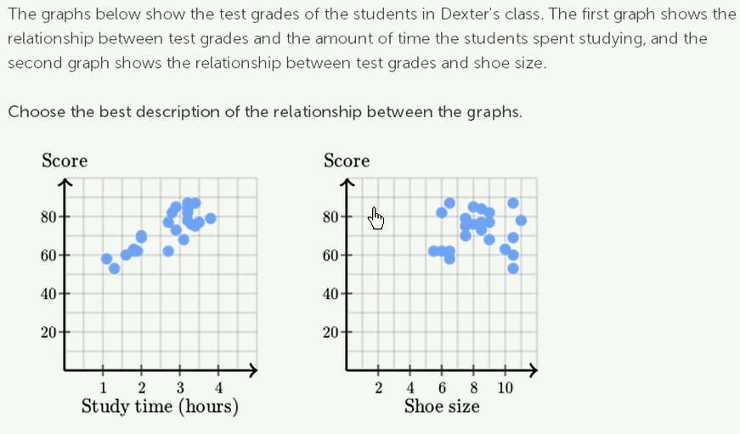

1. Positive linear relationship. You can almost fit a line. It make sense, more time you spent studying the better score you would get. For certain time of studies, some ppl might do better than others, but it does seem like there’s this relationship.
2. There isnt much of a relationship, for a given shoe size, some ppl do well, some ppl do not do very well. You cant fit a line.

Scatter plot: smokers
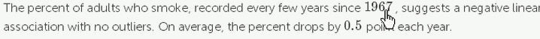
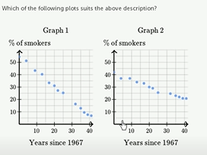
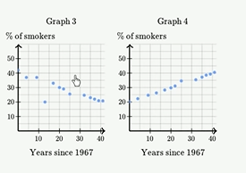

Cuz from 42 in 10 years we drop to 37, difference is 5% in 10 years
that is 0.5 points each year.

Bivariate relationship, linearity, strength and direction
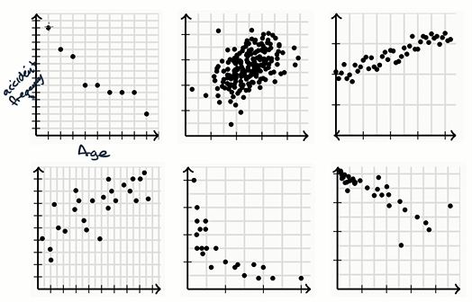

Bivariate data: You r plotting things that takes two variables into consideration and you r trying to see whether there is a pattern on how they relate.
1. Can we fit a line , 2. linear or non-linear Relationship , 3. How strong is it + or – relationship , 4. Outliers .
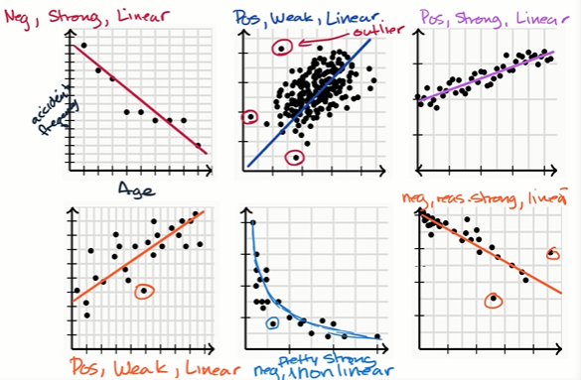

Correlation coefficients

Correlation coefficient intuition
Correlation coefficient are trying to measure how well the linear model can describe the relationship between two variables.
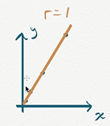
Positive correlation.
Linear relationship.
Ratios are same.

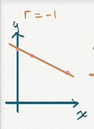
Negative correlation
Negative relationship
Ratios not here cuz one increases, other decreases.
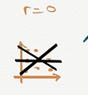

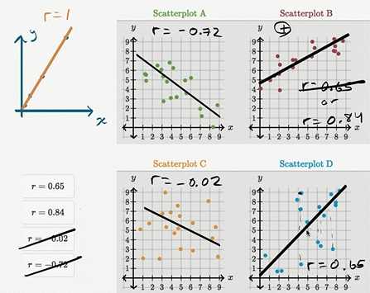

Calculating correlation coefficient r
Bivariate for each x datapoint, there is corresponding y data point.
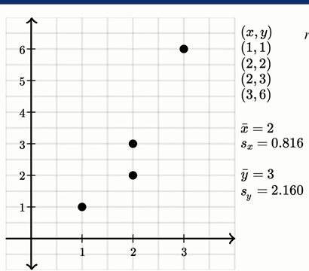
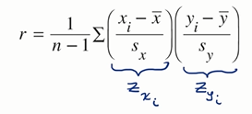

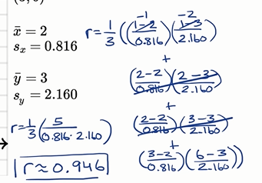

Correlation coefficient tell us how well a line can describe the relationship between x and y.
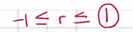
if r is 1, upward sloping line can perfectly describe the relationship, if r is -1 , downward sloping line can perfectly describe the relationship. If r is zero, the line isnt describing the relationship at all..
In our case, r is pretty close to 1. which means the line can pretty well describe the relationship between our x and y.
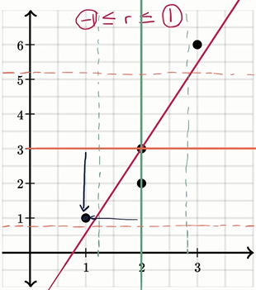
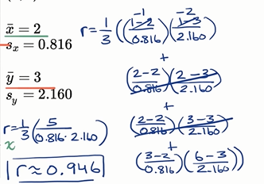

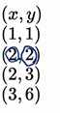

For first pair (1,1).
First we seeing how many S.D away from mean that is -1/0.816 and how many S.D in y direction -2/2.160. Since both were negative, it became a positive value and contributed to our correlation.
For pair (2,2)
x point were right on the mean, bcoz of that the entire term became zero. It would take away from correlation coefficient, u wont be contributing for the sum, but u would be dividing by a slightly higher value.

Introduction to trend lines

Fitting a line to data
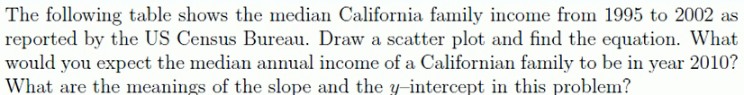
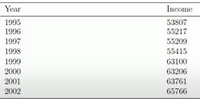

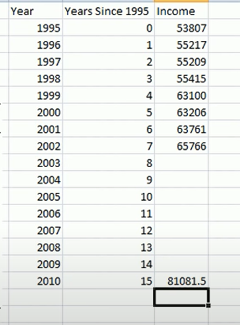
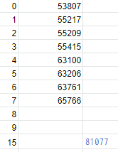

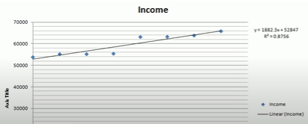

Estimating with linear regression (linear models)
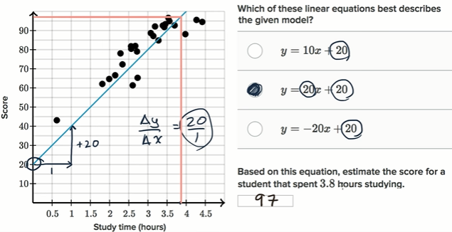

Line of best fit: smoking in 1945
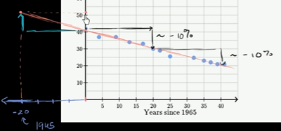

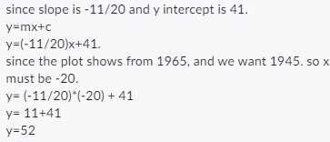

Least-squares regression equations

Introduction to residuals and least squares regression
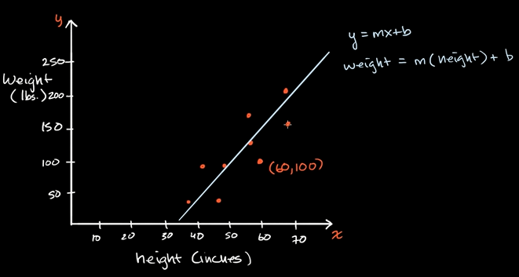

There is some difference between the actual and what is predicted by the line. This is called as Residual.
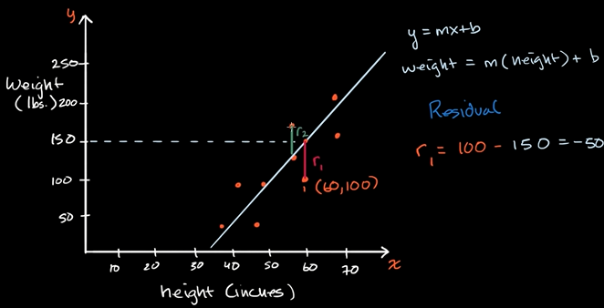
The negative residual tells the actual is smaller than what is predicted ,here by 50.

Residual is good how good your line/regression or model fits given datapoints.
Least square:
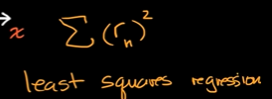
where you find m and b, for a given set of data and find the minimum square of residuals.

Calculating residual example
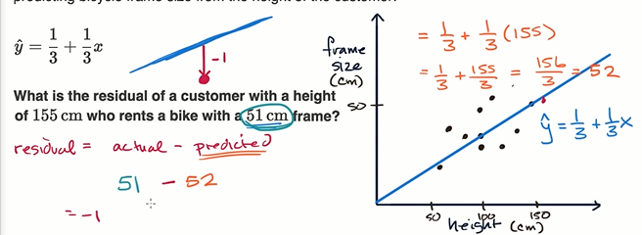

Calculating the equation of a regression line
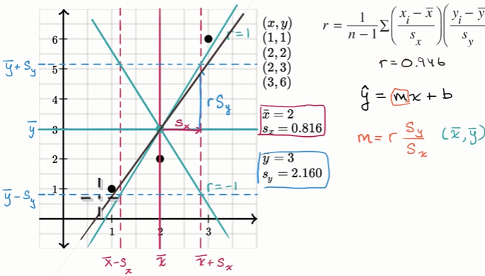
We took the mean of x and y we got x^ and y^.
Thats gonna be our pivot, cuz in our dataset, the points are close to the mean.
Pivot or y-intercept.
Here r ranges from -1 to 1, 1 saying perfect positive correlation and -1 saying perfect negative correlation, zero means the line isnt describing the relationship.

Assessing the fit in least-squares regression

Residual plots
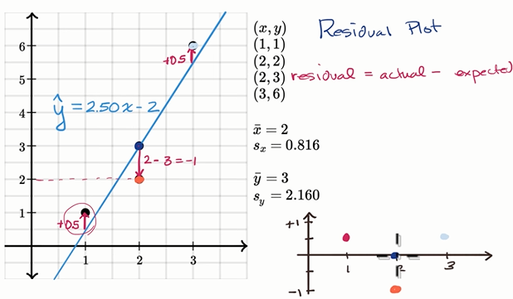

Residual plot: is good at telling how good a fit is, whether the line is good at explaining the relationship between variables.
If u see the point is pretty evenly scattered or randomly scattered above and below the line, you dont start to see any trend here, Then the line is a good model for the data. But if you see some type of trend, some upward trend or curving up and then down. For e.g parabola.
So you can say this line isnt a good fit, you have to do a non-linear model.
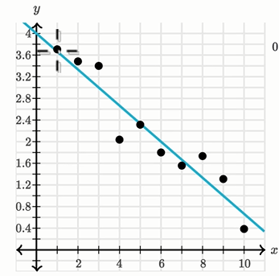
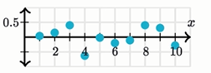

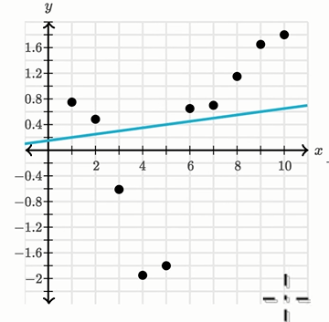
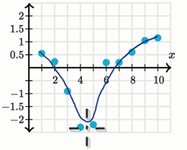

If you see, alot of residuals which are pretty far away from the x-axis in the residual plot, the line isnt a good fit.
The r would be slightly positive, but it wont be close to 1.

R-squared or coefficient of determination
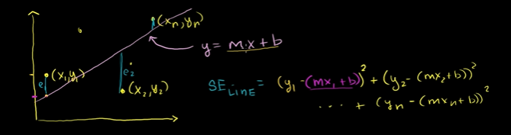

If you want total errors= Squared Error= Summision (y- (mx+b)^2)
We know how to find the line, We can now also calc how much error is in the line.
We want to come up with more meaningful estimate, how good the line is fitting the datapoints we have.

By the variation in x or described by the line.
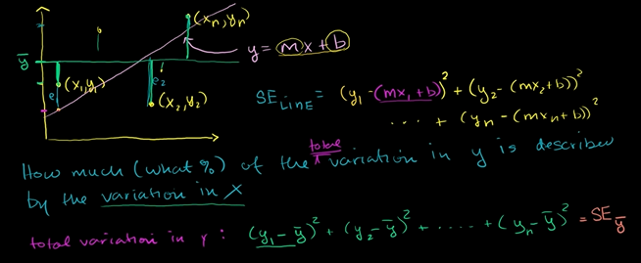

If we divide the total variation by N, we get the avg variance. Here we have total variation.

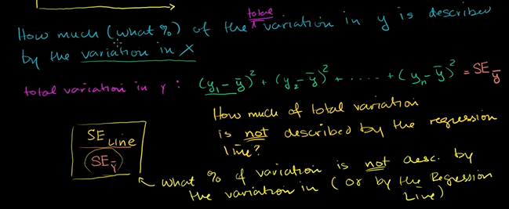
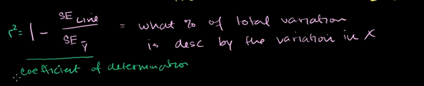
If Squared Error of line is very small, which means, the blue is very small.
Which means very little difference between Actual and predicted.
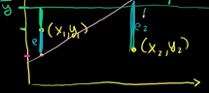
Which tells. The line is very good fit.

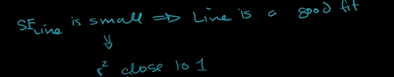
Which means alot of variation in y, is described by variation in x.
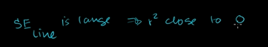
Which tells very little of total variation in y, is descirbe by line.

Standard deviation of residuals or Root – mean – square error (RMSD)
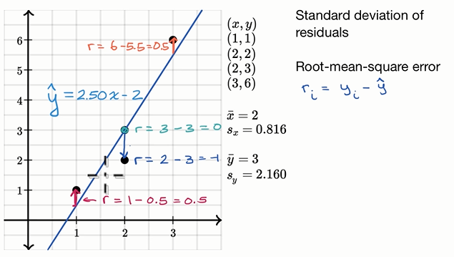

When your actual is below the regression line, you gonna have a negative residual.
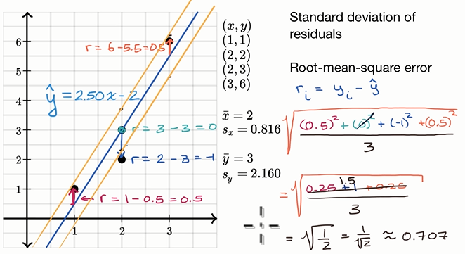

Outliers can affect the S.D ALOT. You may wanna try Absolute value, but this is the standard way.
The lower the S.D, the better the fit is.

Interpreting computer regression data

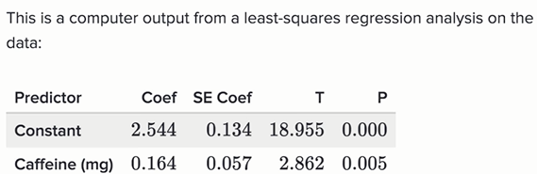
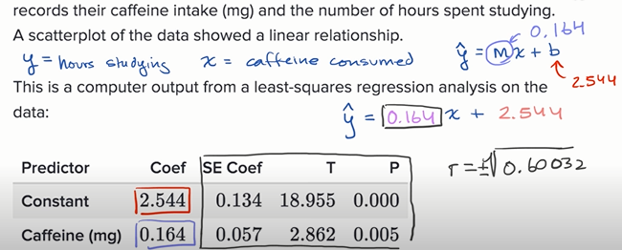
R can take positive or negative value, u need to see the slope is it postive or negative to ans.
SE Coef ,T ,P are for inferential statistics.
For e.g What is the probability the chance we got something to fit this well.
R-Sq(adj) is the adjusted R^2 , we dont have to worry about it too much. When we just thinking about bivariate data. If we have more variables, then to explain hours studying, then we would care about the adjusted R squared.
The S is the S.D of the residuals.

Impact of removing outliers on regression lines
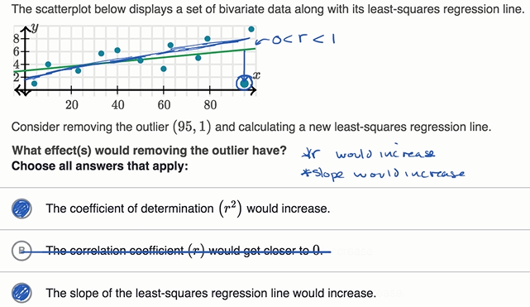
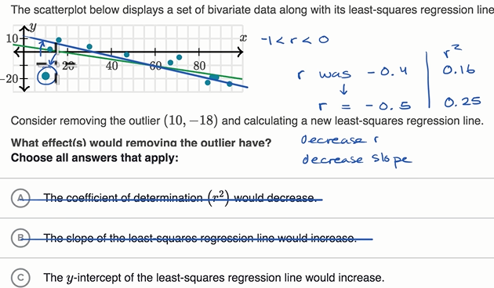

Sals thinked of r ( coefficient of correlation ) which ranges from -1 to 1.
Since we getting a better fit bcoz of removing of outlier, so coefficient of determination would increase.
I thoughted of the formula i.e. 1- SE_{LINE}/SE_{Mean}
if we got better fit, it would be close 1 – 0 =1.

More on Regression

Squared error of regression line
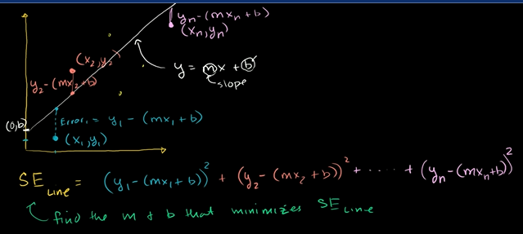

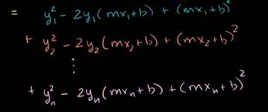

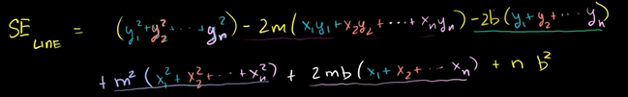
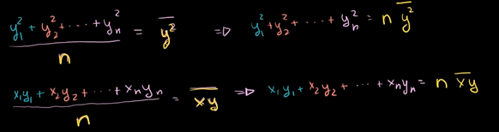
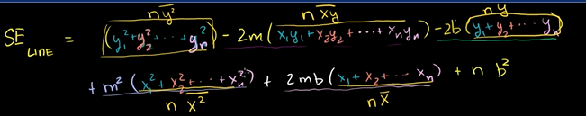

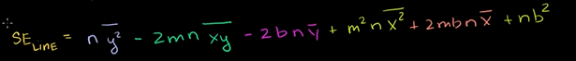
Skipped

Regression line example
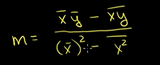

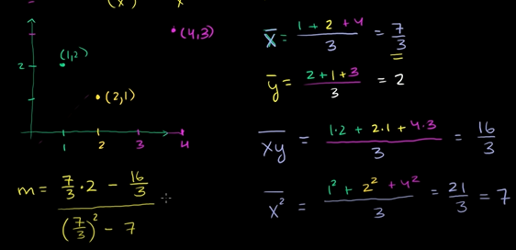
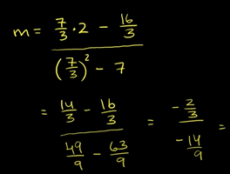
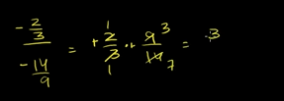

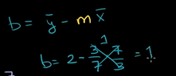
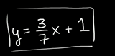

Second regression example
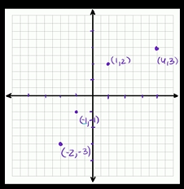
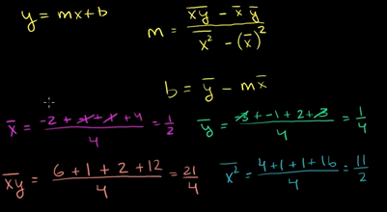

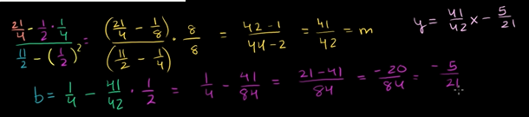

Calculating R-squared
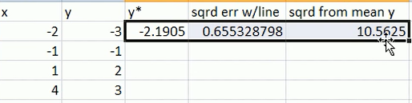

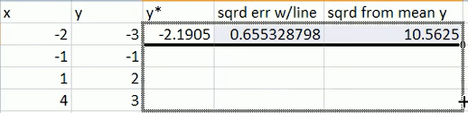

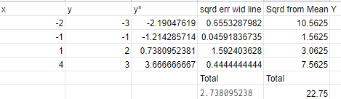

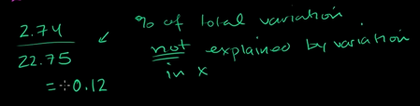

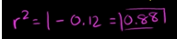

Covariance and the regression line
Covariance bet 2 random var,
Defined as Expected value from the product of the distance of each random variable from their mean or from their expected value.


Its saying how much they vary together.
So you always take a X and a Y for each of the data points, lets say for whole population.
Lets say X is above its mean when Y Is below its mean.
Lets say in population, you sample one instantiation of the random variables. You sample once and you get,
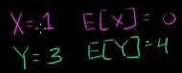

What its telling us, is that atleast the one time that we sampled the random variables X and Y. X was above its expected value when y was below its expected value.
If we keep doing this, lets say for entire population. If this happen for the entire population then it would make sense that they have a negative covariance.
When one goes up, the other one goes down. When other one goes up the one goes done.
If they go up together they both would have a positive variance or they both go down together.
The degree they do it together will tell you the magnitude of the covariance.



We wanna connect this formula to everything we’ve been doing with least squared regression. To show you all of these connections, where really the definition of covariance really becomes useful.
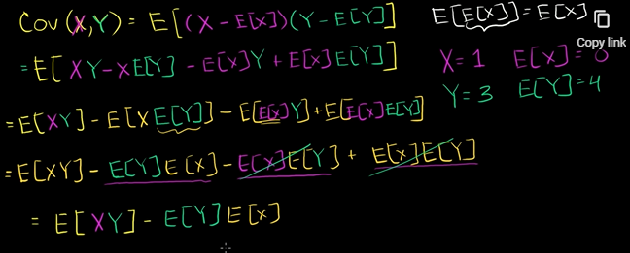
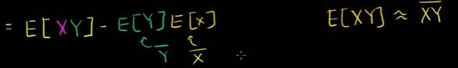

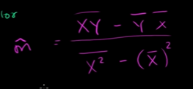

The hat tells, you r approximating the population regression line from the sample.
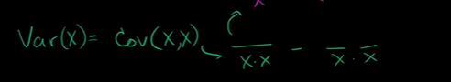

Cov(x,x)= E(x-E(x)^2) = variance.


